1) Within the IPSTransformation package you will need:

* 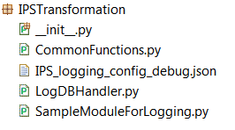**CommonFunctions.py**
  + get_oracle_connection() is required to connect and log to the table
* **IPS_logging_config_debug.json**
  + Configuration file
* **LogDBHandler.py**
  + Class that creates the database log handler
* ***“SampleModuleForLogging.py”***
  + This will be replaced by your module, i.e CalculateIPSShiftWeight, but this particular file does contain examples on how to use the logger. Read this file (comments, code AND print statements) for further information.

2) After set up (explained in ***“SampleModuleForLogging.py”***) use the following as per below:

|  |  |  |
| --- | --- | --- |
| **Sample code** | **Usage** | **RESPONSE_CODE value recorded to table** |
| logger.info(“message”) | To log successful completions | 1 |
| logger.warning(“message”) | To log warnings | 2 |
| logger.error(“message”) | To log errors | 3 |

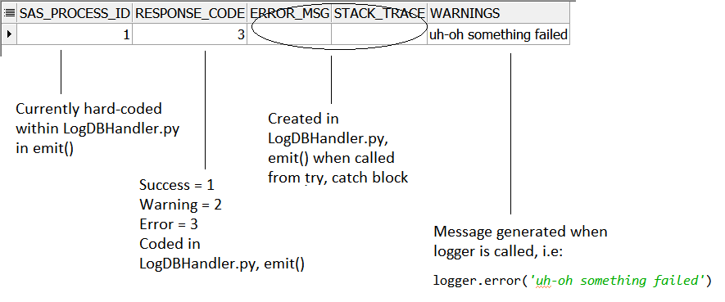**NB:**

* If you change the name of the package from IPSTransformation, or move LogDBHandler.py, the following will need to be amended within IPS_logging_config_debug.json:

